

GDMA v2.1 Installation and Configuration
(GroundWork Distributed Monitoring Agents V2.1)

February 23, 2010
Version 1.2

Prepared by:

Kevin Stone
Thomas Stocking

Table of Contents
Document Summary 5
Document Organization 5
Background 5
Target GroundWork Monitor Server: New Installation 6
Prerequisites 6
NSCA Communication Setup 6
Create GDMA Build Directory 8
Enable Externals 8
Target Server Upgrade 8
Prerequisites 8
Communications setup 9
Create GDMA Build Directory 9
Auto-configuration Setup 9
Background 9
Auto Configuration Operation 9
Create DNS entry for gdma-autohost the points to the GroundWork Monitor Enterprise server 10
Upload and Import GDMA Auto-configuration Profile 11
Create GDMA Auto-configuration Virtual Host 13
Install GDMA Auto-configuration scripts and cron entry 14
Figure 1 Poller Operation 16
Figure 2 Spooler Operation 17
Windows GDMA Setup: New Installations 18
Background 18
Prerequisites 18
GroundWork Monitor Target Server Setup 18
Create Configuration Group for Windows GDMA hosts 18
Configure Group for Windows GDMA hosts 20
Upload and Import GDMA Windows Base OS Host and Service Profile 20
Review and Modify gdma-21-windows host externals properties 21
Modify Target_Server parameter 21
Configure A GDMA Windows Host 23
Add new host to Group 24
Commit changes and Build Externals 25
Windows GDMA Upgrade 26
Prerequisites 26
GroundWork Monitor Target Server Setup 26
Create a New Configuration Group for Windows GDMA 2.1 hosts 26
Configure Group for Windows GDMA 2.1 hosts 26
Perform the Profile Upload and Import Steps as for a New installation 27
Select Windows Hosts for Client Side upgrade 27
Assign Upgraded GDMA Windows Hosts to the gdma-21-windows-host Profile 27
Add Upgraded Windows hosts to New Group 29
Commit changes and Build Externals 30
Client Install/Upgrade for Windows GDMA 30
To uninstall a legacy client: 30
To install a Windows GDMA 2.1 client: 30
Linux GDMA Setup for New Installations 32
Prerequisites 32
GroundWork Monitor Setup 32
Create Configuration Group for Linux/Unix GDMA 2.1 targets 32
Configure Group for Linux/Unix GDMA hosts 33
Upload and Import GDMA Linux Base OS Host and Service Profile 34
Review and Modify gdma-21-linux host externals properties 36
Configure A GDMA Linux Host 37
Add new host to Configuration Group 38
Commit changes and Build Externals 39
Linux GDMA Upgrades 39
Prerequisites 39
GroundWork Monitor Target Server Setup 39
Create a New Configuration Group for Linux GDMA 2.1 hosts 40
Configure Group for Linux GDMA 2.1 hosts 40
Perform the Profile Upload and Import Steps as for a New installation 40
Select Hosts for Client Side upgrade 40
Assign Upgraded GDMA Windows Hosts to the gdma-21-linux-host Profile 40
Add Upgraded hosts to New Group 42
Commit changes and Build Externals 43
Client Install/Upgrade for Linux GDMA 43
To uninstall a legacy client: 43
To install a Linux GDMA 2.1 client: 43
Windows Child Server Setup 45
Prerequisites 45
GroundWork Monitor Setup 45
NSCA Communication Setup 45
Create Windows Child Build Directory 47
Enable Monarch Externals 47
Configure Monarch Group for Windows Child targets 48
Upload and Import Windows Child Profiles 49
Create Windows Child Host 50
Review and Modify windows-child host externals properties 50
Add windows child host to Monarch Group 51
Commit changes and Build Externals 52
Upload and Import Windows Child Target Profiles 52
Create/Configure Windows Target 53
Add new host to Monarch Group 53
Commit changes and Build Externals 54
Install Windows Child Software 54
To install a Windows Child: 55
Appendix A: GDMA Agent Configuration Reference 56
Configuration 56
Global Configuration Parameters 56
Per Service Configuration Parameters 63
Error and Status Messaging 64
GDMA switches 66

Document Summary

This document describes the steps necessary to configure an existing GroundWork Monitor Enterprise server to support GDMA agents, and the Windows Child server. This document describes a basic, first time installation, and upgrades to simple existing installations. Customized versions of GDMA are not discussed in detail. The information in this document is intended to give the GroundWork Monitor Enterprise administrator enough familiarity with the GDMA software to allow them to install and configure the agent on Linux and Windows hosts. Solaris installations are similar, but are documented elsewhere. For information on advanced configurations, contact GroundWork Support.

Document Organization

This document contains the following major sections:

- Target GroundWork Monitor Server setup
- New Install
- Upgrade install
- Windows GDMA
- New Install
- Upgrade Install
- Linux GDMA
- New Install
- Upgrade Install
- Windows Child Server Installation and Upgrade.

In general, the administrator should begin by configuring the Target GroundWork Monitor Server for the common requirements, then move on to configure it one of the agent types, either Windows GDMA, Windows Child, or Linux GDMA. Once one agent type is configured and working, it will be relatively easy to add a second agent type.

Background

The GDMA (GroundWork Distributed Monitoring Agent) was developed primarily as a scaling method for GroundWork Monitor installations. In simple terms, it is an agent that runs independently of the Nagios scheduler in GroundWork, and forwards the state of the monitored services on individual nodes to the GroundWork Monitor Enterprise server using the NSCA protocol. The Nagios instance in GroundWork Monitor processes these results as passive checks.

The configuration information for which services to run on which hosts, the monitoring thresholds, frequency, etc., are hosted on the GroundWork server with http or https, and are retrieved by the GDMA agents.

GDMA agents can send results to multiple GroundWork Monitor Enterprise servers, but can pull configuration data from only one source.

Target GroundWork Monitor Server: New Installation

This section describes the steps necessary to configure a GroundWork Monitor Enterprise server to be a Target server for GDMA results, and a source for GDMA configuration data. This section describes setting up for a new installation of GDMA. If upgrading, see the next section.

Prerequisites

The following prerequisites exist for configuration of a GDMA Target Server

- GroundWork Monitor Enterprise 6.1 or higher correctly installed.
- Communication allowed from GDMA targets on ports 80 (HTTP) or 443(HTTPS)
- Communication allowed from GDMA targets on port 5667 (NSCA)
- Target Server and GDMA monitored hosts clock synchronization
- Administrative access and familiarity with GroundWork and Linux
- Taking a backup of the monarch database is highly recommended before beginning this operation See Bookshelf →System Maintenance→Backup and Restore for details.

NSCA Communication Setup

GroundWork Monitor Enterprise 6.0 and above uses a Nagios Event Broker (NEB) to process passive check results. The NEB is called Bronx. GDMA supports a feature called spooling which will handle network interruptions between GDMA hosts and the GroundWork Monitor server. When that interruption ceases, results are sent with correct timestamps. To support these timestamps, the Bronx configuration file, /usr/local/groundwork/config/bronx.cfg, listener_max_packet_age parameter needs to be updated. Set this value to 900 seconds to allow for 15 minutes of GDMA spooling. Longer durations are possible, but may result in transient overload conditions on the GroundWork server while large data volumes are processed.
Similarly, packets will be dropped by Bronx if they contain a future timestamp. This can be an issue in environments where perfect time synchronization is not possible. Setting the listener_max_packet_imminence parameter will compensate for a small amount of “future” time variance between the monitored node and the Target server. We suggest leaving the default of 1 second unless this is determined to be a problem in the environment.
Finally, the use_client_timestamp parameter should be left at the default of 1, to allow the timestamp from the monitored node to be used. This is useful in collecting the performance data and graphing it in time series graphs in the interface. If this parameter is set to 0, the server timestamp will be used, and graphing may not be accurate.

The following settings are from the Bronx configuration file:
/usr/local/groundwork/config/Bronx.cfg

# LISTENER MAX PACKET AGE
# The max allowed age, in seconds, of the passive check result received.
# Any older results are dropped to the floor.
# The maximum allowed value is "900" seconds.
# Set the value to "0" to accept passive checks with older timestamps.
# If not specified, the value will be "30" seconds.
listener_max_packet_age=900

# LISTENER MAX PACKET IMMINENCE
# The max allowed "future age", in seconds, of the passive check result received.
# Any newer results are dropped to the floor.
# The maximum allowed value is "900" seconds.
# Set the value to "0" to disallow passive checks with newer timestamps.
# If not specified, the value will be "1" second, which should be just
# enough to allow for possible slight discrepancies which can arise even
# between time-synchronized client and server machines. In general, we
# highly recommend that the site use NTP or similar time-synchronization
# software to tie together the software clocks on disparate machines to
# high accuracy, to prevent misunderstandings about when events actually
# occur. Note that time synchronization for a VM guest machine can be
# problematic; see your vendor's documentation on this topic.
#listener_max_packet_imminence=1

# USE CLIENT TIMESTAMP
# This parameter, if set to a positive value, configures the listener thread
# to use the timestamp in the passive check result received for processing,
# rather than the time on the server when the check result is processed.
# To prevent confusion in handling data from clients which are not
# time-synchronized to the server, such a check result timestamp will be
# automatically overridden and replaced with the server timestamp if the
# passive check result timestamp is found by the server to be in the future.
# If not specified, the value will be "1".
#use_client_timestamp=0

If any changes to the Bronx.cfg file are needed, Nagios must be restarted to put them into effect:

/etc/init.d/groundwork restart nagios

Create GDMA Build Directory

This is the location that will be used for building and distribution of GDMA host configurations.

As user root create the directory and change ownership to user Nagios.

#mkdir /usr/local/groundwork/apache2/htdocs/gdma
#chown nagios.nagios /usr/local/groundwork/apache2/htdocs/gdma

Enable Externals

In Configuration→Control→Setup
Check enable externals
Select Save

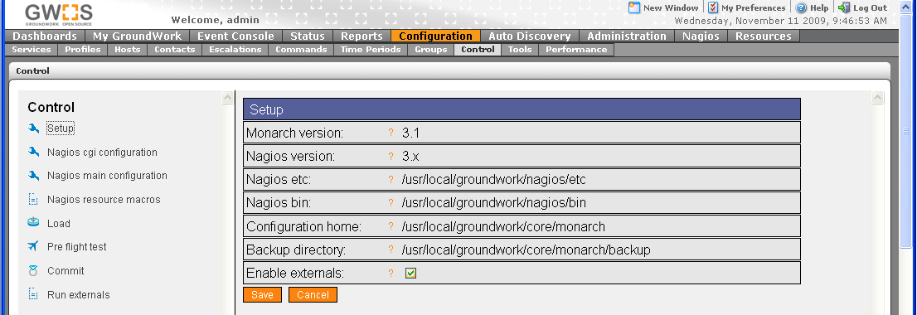

The system is now configured for general GDMA operation. To configure the monitored nodes, see the relevant section (Windows GDMA Setup, Linux GDMA Setup). It is likely that you will wish to take advantage of the Auto-configuration functions as well, so be sure to review the section on Auto-configuration Setup.

Target Server Upgrade

This section describes the steps necessary to upgrade an existing a GroundWork Monitor Enterprise server with a previous version of GDMA configured to be a Target server for GDMA 2.1 agents.

Prerequisites
- An existing GroundWork Monitor Enterprise server version 6.0.1 or higher, configured and running with GDMA 1.x or 2.0.
- Familiarity with GroundWork and Linux System Administration

Communications setup
Verify all the parameters in /usr/local/groundwork/config/bronx.cfg are correct as per the previous section. Restart Nagios if changes are necessary.

Create GDMA Build Directory

This is the location that will be used for building and distribution of GDMA host configurations.

As user root create the directory and change ownership to user Nagios.

#mkdir /usr/local/groundwork/apache2/htdocs/gdma
#chown nagios.nagios /usr/local/groundwork/apache2/htdocs/gdma

All other steps are contained in the relevant upgrade sections. Please proceed to Windows GDMA Upgrade or Linux GDMA Upgrade.
You may wish to take advantage of the Auto-Configuration features of GDMA 2.1. If so, complete the following section before proceeding.

Auto-configuration Setup

Background

The auto configuration feature of GDMA 2.1 enables GDMA agents to be deployed to target systems without needing to provide a host specific configuration at installation time. When GDMA is first installed and started without a configuration it will operate in Auto Configuration mode. While in Auto Configuration mode the agent will periodically perform a basic discovery of the monitored host system and transmit the discovery information to a pre-defined Parent system. The pre-defined host name must be added to DNS, so that the monitored hosts will resolve it as the GroundWork Target server. This information can then be used by the Groundwork administrator to configure a host-specific configuration for the new monitored host. When the host-specific configuration is available, it will be retrieved by the agent and the agent will self-configure and switch to normal operation.

Auto Configuration Operation

The following is a description of the sequence of operations that occur when a new GDMA is deployed in Auto Configuration mode. It is useful to understand this process, so that the messages received and displayed on the GroundWork Monitor Enterprise user interface can be understood.
When the agent is first started both the poller and spooler engines are started.

Basic Poller Operation in Auto Configuration mode

- Poller reads gdma_auto.cfg
- Poller checks for the presence of a local host configuration file.
- Poller attempts to retrieve a host configuration file from the location defined by gdma_auto.cfg.
- If it fails to download a host configuration file it sleeps until Poller_Proc_Interval has expired and starts at step 1

Basic Spooler Operation in Auto Configuration mode

- Spooler reads gdma_auto.cfg
- Spooler checks for the presence of a local host configuration file.
- If the host configuration file is not present the spooler transmits an auto configuration message.
The message is sent via NSCA as a service check result.
The message is sent to the Target server as coming from the host defined by the GDMA_Auto_Host parameter (default is gdma-autohost) and the service defined by GDMA_Auto_Service (default is gdma_auto.
The message payload contains the hostname, ip address and operating system information.
Example:
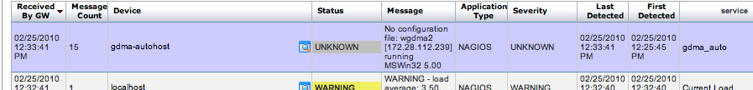

- Spooler sleeps until Spooller_Proc_Interval has expired and restarts starts at step 1

Create DNS entry for gdma-autohost the points to the GroundWork Monitor Enterprise server
The GDMA agent relies on DNS to resolve the pre-configured hostname “gdma-autohost” to the Target server where it will submit its check results, and attempt to pick up its configuration file. Using whatever DNS system is available on your network, ensure that the system to be monitored with GDMA can resolve the name “gdma-autohost” to the GroundWork Monitor Enterprise server.

Upload and Import GDMA Auto-configuration Profile
The GDMA Auto-configuration profile provides a template for the auto-configuration virtual host. In order to properly process the messages from GDMA hosts in Auto Configuration mode, this profile must be loaded, using the following procedure.

In Configuration→Profiles
- Select Profile importer
- Scroll to bottom of screen
- Select Browse and enter location of “gdma_autohost.xml”
- Select upload
- Select Browse and enter location of “service-profile-gdma_auto.xml”
- Select upload

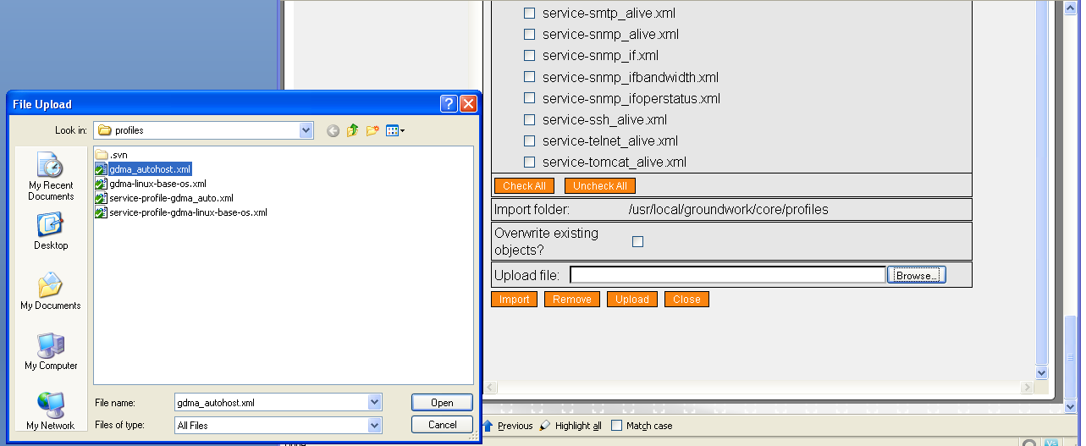

- Toggle Checkbox for gdma_autohost.xml

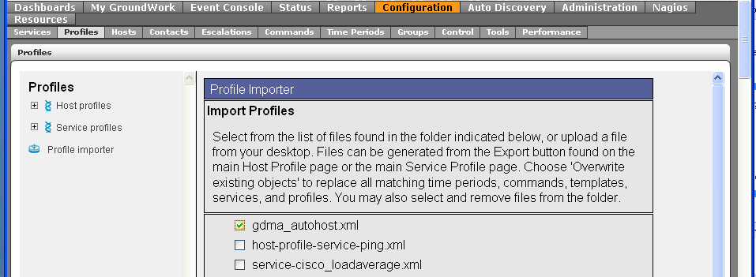
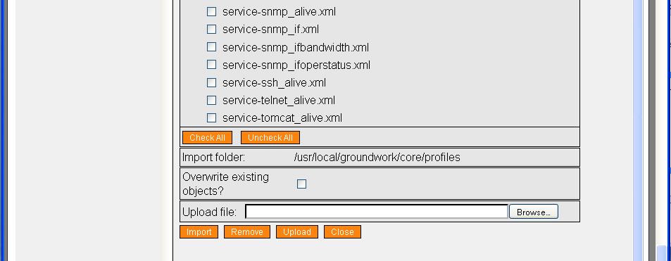

- Select Import
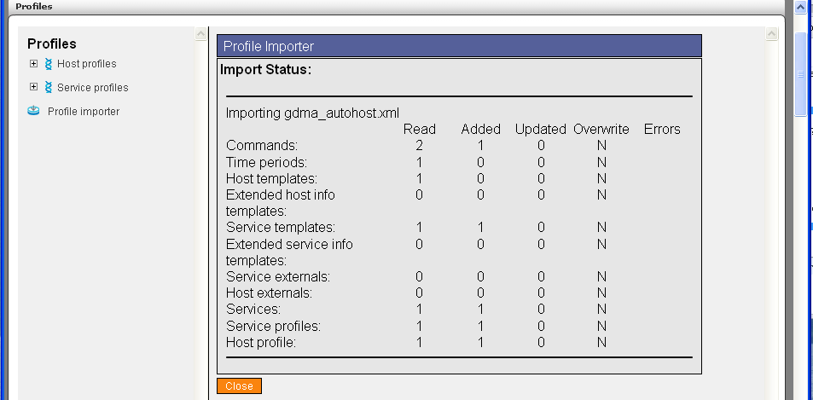

Create GDMA Auto-configuration Virtual Host
This virtual host serves as a collection point for notifications and alerts from un-configured GDMA agents.

In Configuration→Hosts
- Select Host Wizard
- Fill in Host Name “gdma-autohost”
- Fill in alias “gdma-autohost”
- Fill in address “127.0.0.2”
- Select gdma-autohost Host profile

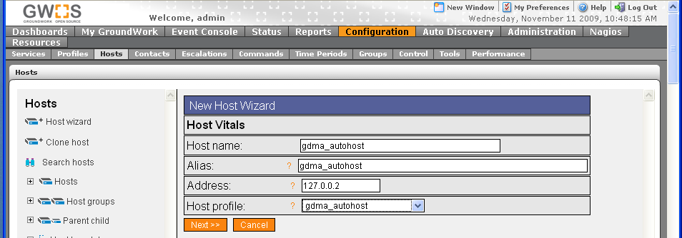

- Select Next,Next,Next,Next,Continue. Note: if you are using clone host or another method for creating this host, please ensure it has no externals associated, or you may see an error when running externals related to the distribution directory. The gdma-autohost and its services should have no externals.

- Commit Changes to activate

The system is now configured to receive auto configuration messages from GDMA targets.

Install GDMA Auto-configuration scripts and cron entry
The GDMA Target Server can be configured to automatically add un-configured hosts to Monarch and generate the External configuration files. This feature is currently only supported when the GDMA Target Server is running GroundWork Monitor 6.1 Enterprise or above.

Setup is done by installing two scripts on the GroundWork Monitor Enterprise server and then enabling a cron job to regularly look for and add the new hosts.

As user root, transfer the GDMA 2.1 auto registration files into a temporary directory on the GroundWork Monitor Enterprise server designated as the Target server, and copy the two Perl scripts to the required location. Then change ownership to user nagios, and flag them executable.

#cp *.pl /usr/local/groundwork/core/monarch/automation/scripts
#chown nagios.nagios /usr/local/groundwork/core/monarch/automation/scripts/gdma_auto.pl
#chown nagios.nagios /usr/local/groundwork/core/monarch/automation/scripts/auto_add_gdma.pl
#chmod +x /usr/local/groundwork/core/monarch/automation/scripts/gdma_auto.pl
#chmod +x /usr/local/groundwork/core/monarch/automation/scripts/auto_add_gdma.pl

Create the cron job by entering the crontab editor and then typing in the single line (in bold, below) to run the above scripts.

#crontab –e –u nagios
SHELL=/bin/bash
PATH=/usr/local/groundwork/common/bin:/usr/local/groundwork/common/sbin

50 23 * * * /usr/local/groundwork/core/reports/utils/dashboard_data_load.pl > /usr/local/groundwork/core/reports/utils/log/dashboard_data_load.log 2>&1
0 1 * * * /usr/local/groundwork/core/reports/utils/dashboard_avail_load.pl > /usr/local/groundwork/core/reports/utils/log/dashboard_avail_load.log 2>&1
0 0 * * * /usr/local/groundwork/common/bin/find /tmp/ -maxdepth 0 -name 'sess_*' -cmin +480 -exec rm \{} \;
0 0 * * * /usr/local/groundwork/common/bin/find /usr/local/groundwork/php/tmp/ -maxdepth 0 -name 'sess_*' -cmin +480 -exec rm \{} \;
0 0 * * * /usr/local/groundwork/common/bin/find /usr/local/groundwork/nagios/var/archives/ -follow -name 'nagios-*' -mtime +60 -exec rm \{} \;
*/5 * * * * (cd /usr/local/groundwork/core/monarch/automation/scripts ; ./gdma_auto.pl ; ./auto_add_gdma.pl –f /usr/local/groundwork/core/monarch/automation/data/gdma_auto.txt) > /dev/null 2>&1

Your choice of host profile and configuration group in later steps may be matched to operating system in the gdma_auto.pl script. The mapping is controlled by the following structure:

"linux;gdma-21-linux-host;unix-gdma-2.1",
"MSWin32;gdma-21-windows-host;windows-gdma-2.1",
"linux 2.6.9-42.0.3.elsmp;gdma-21-linux-host;unix-gdma-2.1",
"MSWin32 5.00;gdma-21-windows-host;windows-gdma-2.1"

You may change these defaults, or add matches to the list, as long as you maintain the quoted, comma-delimited string of:

os string;host_profile;monarch_group

Note that the last encountered match is what will be used, so you should place general matches first, more specific matches later in the list.

GDMA Target Server configuration for auto-configuration is now complete. You should periodically check your configuration for new hosts as you deploy the GDMA in your organization. These hosts should be placed in hostgroups and the configuration committed.
Figure 1 Poller Operation
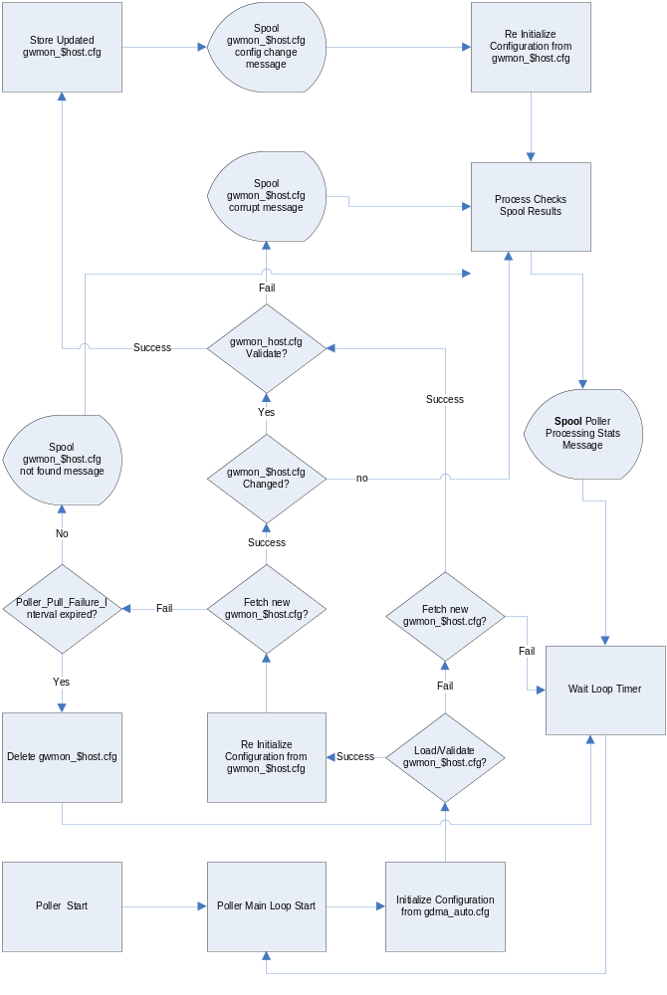
Figure 2 Spooler Operation
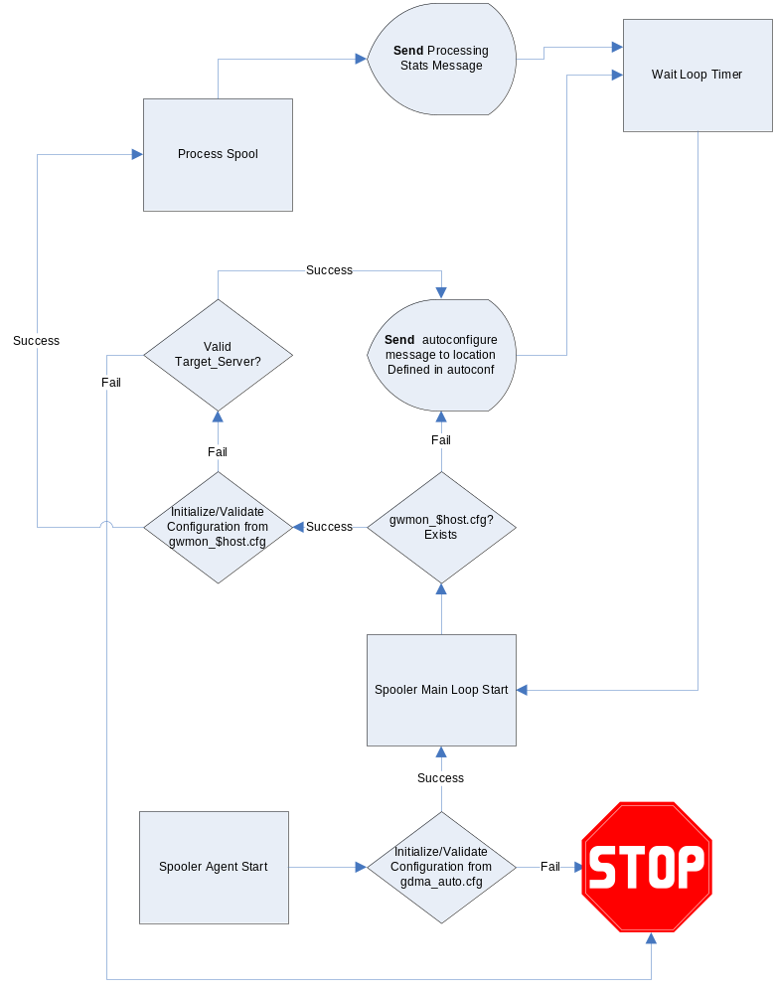

Windows GDMA Setup: New Installations

Background

The Windows GDMA installation requires several new profiles to be present on the Target GroundWork Monitor Enterprise server. These profiles must be loaded on the system and applied to the GDMA monitored node hosts. Windows GDMA hosts must be additionally organized into Configuration Groups. Configuration groups (aka Monarch Groups) are used to control creation of external definitions used by GDMA agents.
This section covers setting up these parameters in a new installation of GDMA.

Prerequisites

The following prerequisites exist for configuring Windows GDMA Agents:

- GroundWork Monitor Enterprise 6.1 correctly installed.
- GroundWork Monitor GDMA Target Server Configuration complete.
- Administrative access to Groundwork and monitored systems and familiarity with the administration of Linux, GroundWork Monitor, and Windows systems
- Taking a backup of the monarch database is highly recommended before beginning this operation See Bookshelf →System Maintenance→Backup and Restore for details

GroundWork Monitor Target Server Setup
The following steps need to be performed on the GroundWork Monitor Enterprise server designated as the Target Server for the Windows GDMA monitored hosts.

Create Configuration Group for Windows GDMA hosts
In Configuration→Groups→
  - Select New
  - Fill in Group Name field E.G. “windows-gdma-2.1”
  - Select Add to create the monarch group.

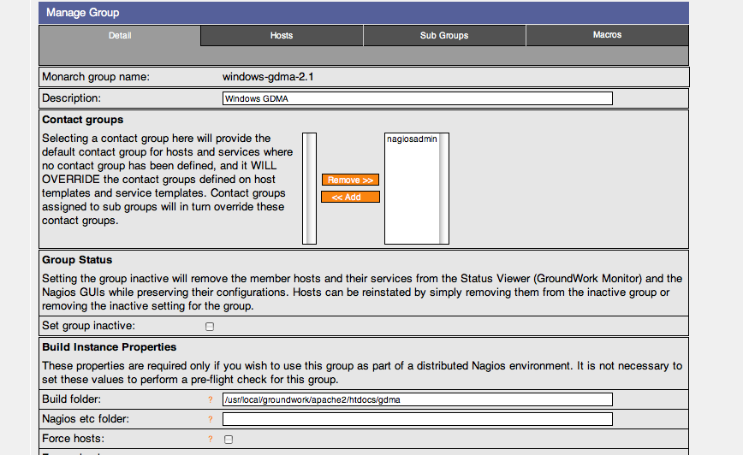

Configure Group for Windows GDMA hosts

In Configuration→Groups→
- Select detail page of windows-gdma-2.1
- Fill in Description[Optional]
“Group for configuration of gdma targets”
- Fill in Build directory
“/usr/local/groundwork/apache2/htdocs/gdma”
- Leave all other fields blank
- Select Save

Upload and Import GDMA Windows Base OS Host and Service Profile
The Windows Base OS profile provides configuration parameters for the creation of Windows monitored nodes.

In Configuration→Profiles
- Select Profile importer
- Scroll to bottom of screen
- Select Browse and enter location of “gdma-21-windows-host.xml”
- Select upload
- Select Browse and enter location of “service-profile-gdma-21-windows.xml”
- Select upload
- Select Browse and enter location of “perfconfig-gdma-21-windows.xml”
- Select upload
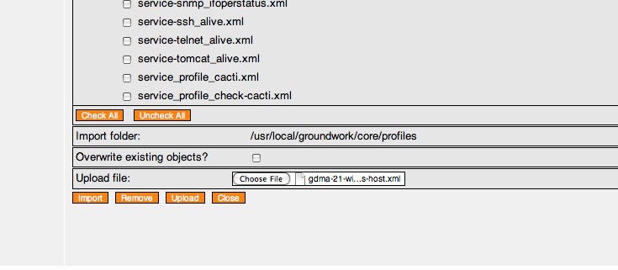
- Toggle Checkbox for gdma-21-windows-host.xml

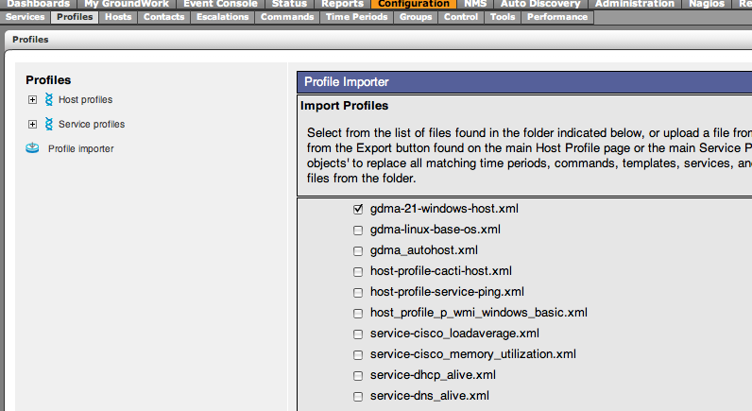

- Select Import.

Review and Modify gdma-21-windows host externals properties
In Configuration→Hosts→Host Externals
- Select Modify
- Select gdma-21-windows

Modify Target_Server parameter
This parameter controls where GDMA agents will download their configurations from and where they will send check results. The parameter must be in the form of a URL. This parameter is normally set to the hostname or IP address of the Master system. For details on this and other configuration parameters see Appendix A: GDMA Agent Configuration Reference. If you are using Auto-configuration, you may set this to http://gdma-autohost.

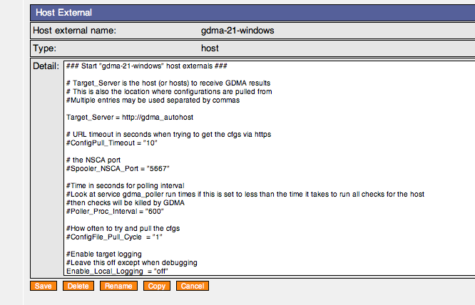
- Select Save.

Configure A GDMA Windows Host

If you are using auto-configuration, you may skip this step.

In Configuration→Hosts
- Select Host Wizard
- Fill in Host Name E.G “2000pro”
- Fill in alias E.G.“2000pro”
- Fill in address E.G.“196.168.11.72”
- Select gdma-21-windows-host Host profile
- Select Next,Next,Next,Next,Continue

Add new host to Group
If you are using auto-configuration, you may skip this step.

In Configuration→Groups
- Expand Groups
- Expand windows-gdma-21
- Select Detail
- Select Hosts Tab
- Toggle Checkbox for host E.G. 2000pro
- Select Add Hosts
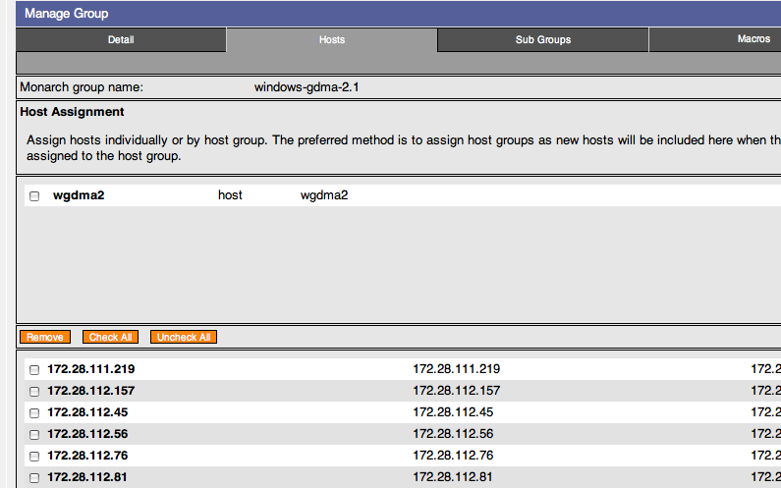

Host will appear in the upper field as an assigned host.

Commit changes and Build Externals
To commit changes to groundwork and create gdma configuration file

In Configuration→Control
- Select Commit, Backup, Commit
- Select Run externals

The configuration file will be created in “/usr/local/groundwork/apache2/htdocs/gdma” as defined in the windows-gdma monarch group. The filename will be gwmon_$hostname.cfg in this example gwmon_2000pro.cfg

#ls -al /usr/local/groundwork/apache2/htdocs/gdma/gwmon_2000pro.cfg
-rw-r--r-- 1 nagios nagios /usr/local/groundwork/apache2/htdocs/gdma/gwmon_2000pro.cfg
#

Windows GDMA Upgrade

Background

Upgrading Windows GDMA systems will likely be a phased project. This document describes the extra steps needed when upgrading a system with existing GDMA agents.

Prerequisites

The following prerequisites exist for upgrading Windows GDMA Agents:

- GroundWork Monitor Enterprise 6.0.1 or above correctly installed.
- GroundWork Monitor GDMA Target Server Configuration complete.
- Administrative access to Groundwork and monitored systems and familiarity with the administration of Linux, GroundWork Monitor, and Windows systems
- Taking a backup of the monarch database is highly recommended before beginning this operation See Bookshelf →System Maintenance→Backup and Restore for details
- (Optional) If auto-configuration features of GDMA 2.1 are desired, the auto-configuration setup should be completed prior to starting this process.

GroundWork Monitor Target Server Setup
The following steps need to be performed on the GroundWork Monitor Enterprise server designated as the Target Server for the Windows GDMA monitored hosts.

Create a New Configuration Group for Windows GDMA 2.1 hosts
In Configuration→Groups→
  - Select New
  - Fill in Group Name field E.G. “windows-gdma-2.1”
  - Select Add to create the monarch group.

Configure Group for Windows GDMA 2.1 hosts

In Configuration→Groups→
- Expand Groups
- Select group windows-gdma-2.1
- Select detail page of windows-gdma-2.1
- Fill in Description [Optional]
“Group for configuration of gdma targets”
- Fill in Build directory
“/usr/local/groundwork/apache2/htdocs/gdma”
- Leave all other fields blank
- Select Save

Perform the Profile Upload and Import Steps as for a New installation

Do the following steps as you would for a new installation:
- Upload and Import GDMA Windows Host and Service Profile
- Review and Modify gdma-21-windows host externals properties

Select Windows Hosts for Client Side upgrade
At this point, you must upgrade the Windows Client software by uninstalling the old GDMA and installing the new package.
You can pause at this point and perform this task on a set of existing Windows GDMA hosts, or you can continue with this process up to the point where you are about to build externals and/or commit the changes. Either way, it would be advisable to schedule downtime on the set of hosts to be upgraded in this phase.

Assign Upgraded GDMA Windows Hosts to the gdma-21-windows-host Profile

In Configuration→Profiles
- Select Host Profiles, expand Modify
- Select gdma-21-windows-host
- Select the Assign Hosts tab
- Assign the hosts to be upgraded
- Click Save
- Select the Apply tab
- Choose Apply to Hosts
- Choose either Merge with existing services or Replace existing services. Note: if you merge, you must manually remove the services from the legacy GDMA. The services associated with the new GDMA version are named differently, so they will not interfere with existing services. If you wish to rename them to the old names, you may do so once you are finished migrating. Replacing existing services is recommended unless you have custom services added that you wish to keep.
- Click Apply
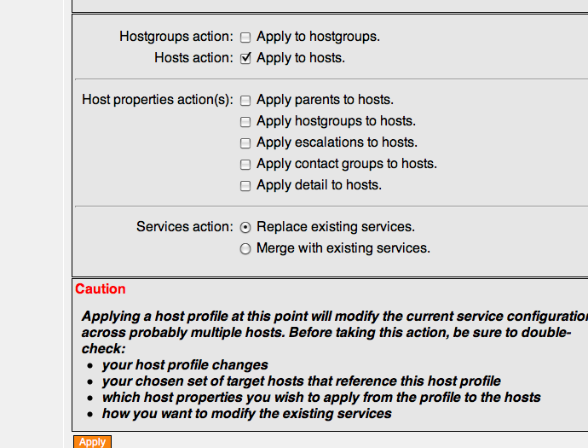

Add Upgraded Windows hosts to New Group
In Configuration→Groups
- Expand Groups
- Expand windows-gdma-2.1
- Select Detail
- Select Hosts Tab
- Toggle Checkbox for upgraded hosts
- Select Add Hosts

Host will appear in the upper field as an assigned host.

Commit changes and Build Externals
To commit changes to groundwork and create GDMA configuration file. Note: do this when you have completed the GDMA installations on the client systems.

In Configuration→Control
- Select Commit, Backup, Commit
- Select Run externals

The configuration file will be created in “/usr/local/groundwork/apache2/htdocs/gdma” as defined in the windows-gdma-2.1 monarch group. The filename will be gwmon_$hostname.cfg in this example gwmon_2000pro.cfg

#ls -al /usr/local/groundwork/apache2/htdocs/gdma/gwmon_2000pro.cfg
-rw-r--r-- 1 nagios nagios /usr/local/groundwork/apache2/htdocs/gdma/gwmon_2000pro.cfg
#

Client Install/Upgrade for Windows GDMA

Use this procedure to install the Windows GDMA on a Windows hosts. If upgrading, you must first uninstall the legacy GDMA client.

To uninstall a legacy client:
- Access the Windows client user interface.
- Start a command window
- Stop the GDMA service with the command:
- net stop gdma
- Remove the gdma service with the command:
- sc delete gdma
- Backup any custom plugins you may have added to the GDMA in the c:\groundwork directory structure. You will need to move these to the new location.
- (Optional) Delete the directory c:\groundwork and all subdirectories.

To install a Windows GDMA 2.1 client:
- Access the Windows client user interface
- Transfer the binary installer file to a temporary location on the local disk
- Start a command window
- Change to the temporary directory
- Type the name of the binary installer
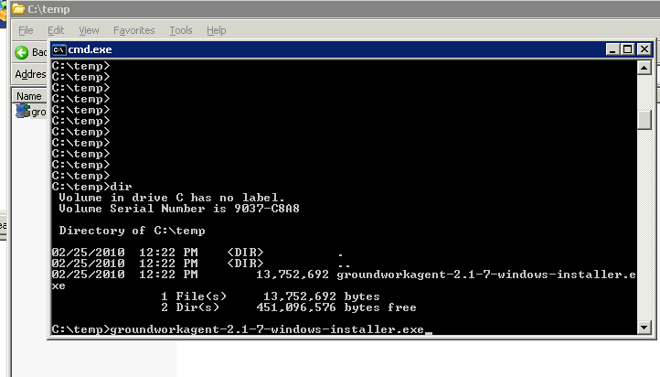

Follow the prompts on the screen. If you are using the auto-configuration feature, you should leave the target server as gdma-autohost. If not, you should fill in the Target server hostname or IP address.

If you wish to install the GDMA via a scripted method, such as a software distribution package or a batch script, you may wish to take advantage of the unattended mode option. Type the name of the binary installer followed by “--help” for a list of available options.

Linux GDMA Setup for New Installations

Prerequisites

The following prerequisites exist for configuring Linux GDMA Agents:

- GroundWork Monitor Enterprise 6.0.1 or above correctly installed.
- GroundWork Monitor GDMA Target Server Configuration complete.
- Administrative access to Groundwork and Target systems and familiarity with Groundwork, Nagios and Monarch
- Taking a backup of the monarch database is highly recommended before beginning this operation See Bookshelf →System Maintenance→Backup and Restore for details

GroundWork Monitor Setup

Create Configuration Group for Linux/Unix GDMA 2.1 targets
In Configuration→Groups→
  - Select New
  - Fill in Group Name feild E.G. “unix-gdma-2.1”
  - Select Add to create the monarch group.

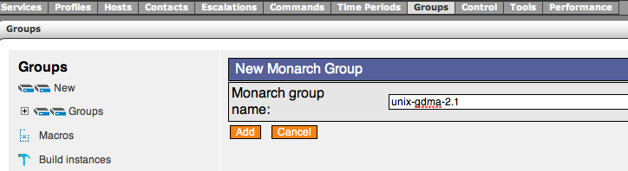

Configure Group for Linux/Unix GDMA hosts
Configuration groups are used to control creation of external definitions used by GDMA agents.

In Configuration→Groups→
- Expand Groups
- Select group unix-gdma-2.1
- Select detail page of unix-gdma-2.1
- Fill in Description[Optional]
“Group for configuration of Linux gdma systems”
- Fill in Build directory
“/usr/local/groundwork/apache2/htdocs/gdma”
- Leave all other fields blank
- Select Save

Upload and Import GDMA Linux Base OS Host and Service Profile
The Linux Base OS profile provides configuration parameters for the creation of Linux targets.

In Configuration→Profiles
- Select Profile importer
- Scroll to bottom of screen
- Select Browse and enter location of “gdma-21-linux-host.xml”
- Select upload
- Select Browse and enter location of “service-profile-gdma-21-linux.xml”
- Select upload
- Select Browse and enter location of “perfconfig-gdma-21-linux.xml”
- Select upload
- Toggle Checkbox for gdma-21-linux-host.xml
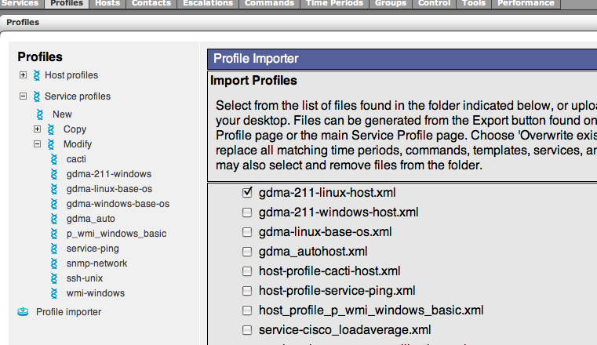

- Select Import

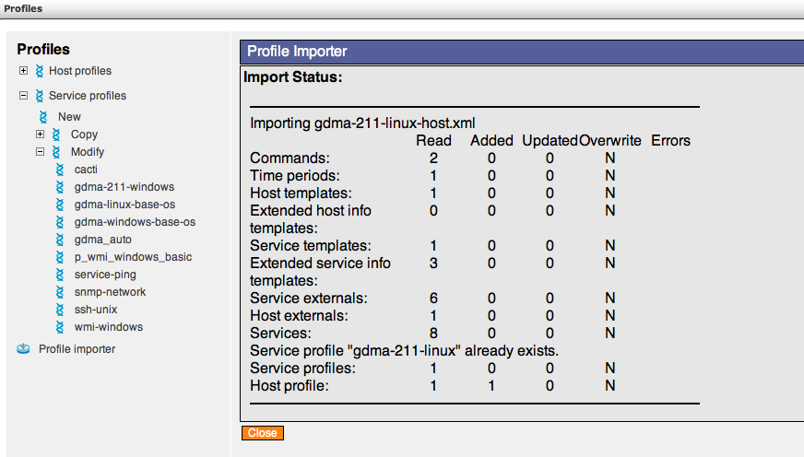

Review and Modify gdma-21-linux host externals properties
In Configuration→Hosts→Host Externals
- Select Modify
- Select gdma-21-linux

Modify Target_Server parameter
This parameter controls where GDMA agents will download their configurations from and where they will send check results. The parameter must be in the form of a url. This parameter is normally set to the hostname or ip address of the Master system. For details on this and other configuration parameters see appendix A: GDMA Agent Configuration Reference.

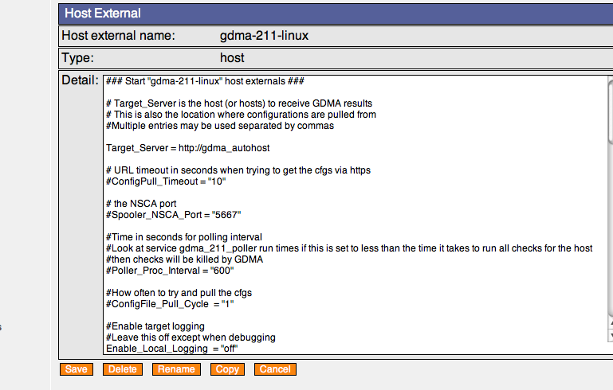

Configure A GDMA Linux Host

In Configuration→Hosts
- Select Host Wizard
- Fill in Host Name E.G “linux_gdma”
- Fill in alias E.G.“gdma_test”
- Fill in address E.G.“196.168.11.220”
- Select gdma-21-linux-host Host profile

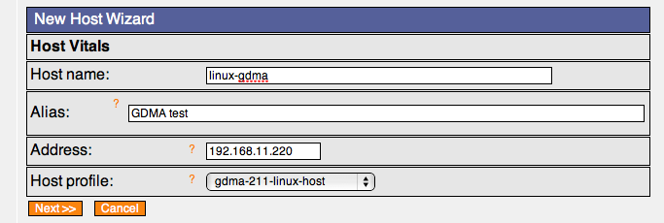
- Select Next,Next,Next,Next,Continue

Add new host to Configuration Group
In Configuration→Groups
- Expand Groups
- Expand unix-gdma-2.1
- Select Detail
- Select Hosts Tab
- Toggle Checkbox for host E.G. gdma_test
- Select Add Hosts

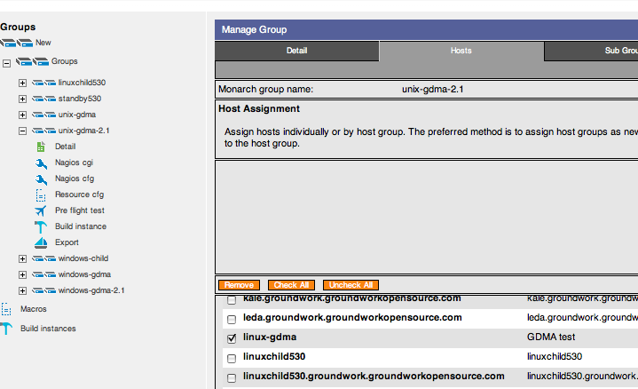
Host will appear in the upper field as an assigned host.

Commit changes and Build Externals
To commit changes to groundwork and create gdma configuration file

In Configuration→Control
- Select Commit, Commit
- Select Run externals

The configuration file will be created in “/usr/local/groundwork/apache2/htdocs/gdma” as defined in the unix-gdma-2.1 monarch group. The filename will be gwmon_$hostname.cfg in this example gwmon_linux-gdma.cfg

#ls -al /usr/local/groundwork/apache2/htdocs/gdma/gwmon_linux-gdma.cfg
-rw-r--r-- 1 nagios nagios /usr/local/groundwork/apache2/htdocs/gdma/gwmon_linux-gdma.cfg
#

Linux GDMA Upgrades

Background

Upgrading Linux GDMA systems will likely be a phased project. This document describes the extra steps needed when upgrading a system with existing GDMA agents.

Prerequisites

The following prerequisites exist for upgrading Linux GDMA Agents:

- GroundWork Monitor Enterprise 6.1 correctly installed.
- Working Linux GDMA hosts being monitored, with all associated profiles, groups and directories created.
- GroundWork Monitor GDMA Target Server Configuration complete.
- Administrative access to Groundwork and monitored systems and familiarity with the administration of Linux and GroundWork Monitor systems
- Taking a backup of the monarch database is highly recommended before beginning this operation See Bookshelf →System Maintenance→Backup and Restore for details
- (Optional) If auto-configuration features of GDMA 2.1 are desired, the auto-configuration setup should be completed prior to starting this process.

GroundWork Monitor Target Server Setup
The following steps need to be performed on the GroundWork Monitor Enterprise server designated as the Target Server for the Linux GDMA monitored hosts.

Create a New Configuration Group for Linux GDMA 2.1 hosts
In Configuration→Groups→
  - Select New
  - Fill in Group Name field E.G. “unix-gdma-2.1”
  - Select Add to create the monarch group.

Configure Group for Linux GDMA 2.1 hosts

In Configuration→Groups→
- Expand Groups
- Select group unix-gdma-2.1
- Select detail page of unix-gdma-2.1
- Fill in Description [Optional]
“Group for configuration of gdma on Linux”
- Fill in Build directory
“/usr/local/groundwork/apache2/htdocs/gdma”
- Leave all other fields blank
- Select Save

Perform the Profile Upload and Import Steps as for a New installation

Do the following steps as you would for a new installation:
- Upload and Import GDMA Linux Host and Service Profile
- Review and Modify gdma-21-linux host externals properties

Select Hosts for Client Side upgrade
At this point, you must upgrade the Linux GDMA Client software by uninstalling the old GDMA and installing the new package.
You can pause at this point and perform this task on a set of existing Linux GDMA hosts, or you can continue with this process up to the point where you build externals and/or commit the changes. Either way, it would be advisable to schedule downtime on the set of hosts to be upgraded in this phase.

Assign Upgraded GDMA Windows Hosts to the gdma-21-linux-host Profile

In Configuration→Profiles
- Select Host Profiles, expand Modify
- Select gdma-21-linux-host
- Select the Assign Hosts tab
- Assign the hosts to be upgraded
- Click Save
- Select the Apply tab
- Choose Apply to Hosts
- Choose either Merge with existing services or Replace existing services. Note: if you merge, you must manually remove the services from the legacy GDMA.
- Click Apply

Add Upgraded hosts to New Group
In Configuration→Groups
- Expand Groups
- Expand unix-gdma-2.1
- Select Detail
- Select Hosts Tab
- Toggle Checkbox for upgraded hosts
- Select Add Hosts

Host will appear in the upper field as an assigned host.

Commit changes and Build Externals
To commit changes to groundwork and create gdma configuration file.

In Configuration→Control
- Select Commit, Backup, Commit
- Select Run externals

The configuration file will be created in “/usr/local/groundwork/apache2/htdocs/gdma” as defined in the windows-gdma monarch group. The filename will be gwmon_$hostname.cfg in this example gwmon_linux1.cfg

#ls -al /usr/local/groundwork/apache2/htdocs/gdma/gwmon_linux1.cfg
-rw-r--r-- 1 nagios nagios /usr/local/groundwork/apache2/htdocs/gdma/gwmon_linux1.cfg
#

Client Install/Upgrade for Linux GDMA

Use this procedure to install the Linux GDMA on Linux hosts. If upgrading, you must first uninstall the legacy GDMA client.

To uninstall a legacy client:
- Access the client command line interface.
- Backup any custom plugins you may have added to the GDMA in the /usr/local/groundwork directory structure. You will need to move these to the new location.
- Delete the directory /usr/local/groundwork and all subdirectories.
- Type chkconfig gdma off
- Type /etc/init.d/gdma stop
- Remove the file /etc/init.d/gdma file:
rm /etc/init.d/gdma
- Remove the entire /usr/local/groundwork directory
rm -Rf /usr/local/groundwork
Note: Linux GDMA 2.1 can be uninstalled with the script:
/usr/local/groundwork/uninstall

To install a Linux GDMA 2.1 client:
- Access the client command line interface
- Transfer the binary installer file to a temporary location on the local disk
- Change to the temporary directory
- Type:
chmod +x groundworkagent-2.1-14-linux-32-installer.bin
to make the installer executable. Substitute the name of your installer: note: Linux GDMA has a 32 and a 64 bit version. Please select the correct one for your architecture.
- Type the name of the binary installer to launch it, e.g:
./groundworkagent-2.1-14-linux-32-installer.bin
Follow the prompts on the screen. If you are using the auto-configuration feature, you should leave the target server as gdma-autohost. If not, you should fill in the Target server hostname or IP address.

If you wish to install the GDMA via a scripted method, such as a software distribution package or a batch script, you may wish to take advantage of the unattended mode option. Type the name of the binary installer followed by “--help” for a list of available options.

Windows Child Server Setup

This document describes the steps necessary to configure an existing GroundWork Monitor Enterprise server to support a Windows Child Server. This document describes a basic installation. For information on advanced configurations contact GroundWork Support.

Prerequisites

The following prerequisites exist for configuration of a Windows Child Target Server

- GroundWork Monitor Enterprise 6.0.1 correctly installed.
- Communication allowed from Windows Child to Master on port 80 (HTTP) or 443(HTTPS)
- Communication allowed from Windows Child to Master on port 5667 (NSCA)
- Target Server and Windows Child clock synchronization
- Administrative access and familiarity with GroundWork, Nagios and Monarch.
- Taking a backup of the monarch database is highly recommended before beginning this operation See Bookshelf →System Maintenance→Backup and Restore for details.

GroundWork Monitor Setup

NSCA Communication Setup

GroundWork Monitor Enterprise 6.0.1 uses a Nagios Event Broker (NEB) to process passive check results. The NEB is called Bronx. Windows Child supports a feature called spooling which will handle network interruptions between the Windows Child host and the GroundWork Monitor server. When that interruption ceases, results are sent back with correct timestamps. To support these timestamps, the Bronx configuration file, /usr/local/groundwork/config/bronx.cfg, listener_max_packet_age parameter needs to be updated. Set this value to 900 seconds to allow for GDMA spooling.

# LISTENER MAX PACKET AGE
# The max allowed age, in seconds, of the passive check result received.
# Any older results are dropped to the floor.
# The maximum allowed value is "900" seconds.
# Set the value to "0" to accept passive checks with older timestamps.
# If not specified, the value will be "30" seconds.
listener_max_packet_age=900

Create Windows Child Build Directory

This is the location that will be used for building and distribution of monitored Windows host configurations.

As user root create the directory and change ownership to user Nagios.

#mkdir /usr/local/groundwork/apache2/htdocs/wchild1
#chown nagios.nagios /usr/local/groundwork/apache2/htdocs/wchild1

# ls -al /usr/local/groundwork/apache2/htdocs/
total 44
drwxr-xr-x 4 nagios nagios 4096 Nov 11 09:54 .
drwxr-xr-x 15 nagios nagios 4096 Nov 11 08:29 ..
-rw-r--r-- 1 nagios nagios 2205 Dec 14 2005 apache_pb22_ani.gif
-rw-r--r-- 1 nagios nagios 2410 Dec 14 2005 apache_pb22.gif
-rw-r--r-- 1 nagios nagios 1502 Dec 14 2005 apache_pb22.png
-rw-r--r-- 1 nagios nagios 2326 Nov 20 2004 apache_pb.gif
-rw-r--r-- 1 nagios nagios 1385 Nov 20 2004 apache_pb.png
-rw-r--r-- 1 nagios nagios 1150 Jan 22 2009 favicon.ico
drwxr-xr-x 2 nagios nagios 4096 Nov 11 09:54 wchild1
-rwxr-xr-x 1 nagios nagios 993 Nov 9 06:46 index.html
drwxr-xr-x 2 nagios nagios 4096 Nov 11 08:30 rrd

Enable Monarch Externals

In Configuration→Control→Setup
  - Check enable externals
  - Select Save

Configure Monarch Group for Windows Child targets
Monarch groups are used to control creation of monarch external definitions used by GDMA agents.

In Configuration→Groups→
- Expand Groups
- Select group windows-gdma
- Select detail page of windows-gdma
- Fill in Description[Optional]
  - “Monarch group for configuration of gdma targets”
- Fill in Build directory
  - “/usr/local/groundwork/apache2/htdocs/wchild1”
- Leave all other fields blank
- Select Save
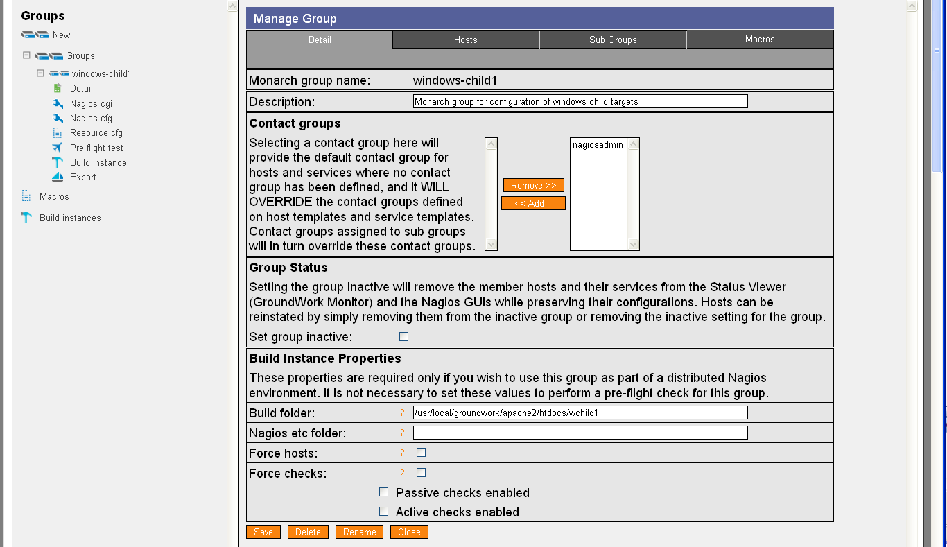

Upload and Import Windows Child Profiles
The Windows Child profile provides a template for the Windows Child host.

In Configuration→Profiles
- Select Profile importer
- Scroll to bottom of screen
- Select Browse and enter location of “windows_child.xml”
- Select upload
- Select Browse and enter location of “service-profile-windows_child.xml”
- Select upload
- Select Browse and enter location of “perfconfig-windows-child.xml”
- Select upload

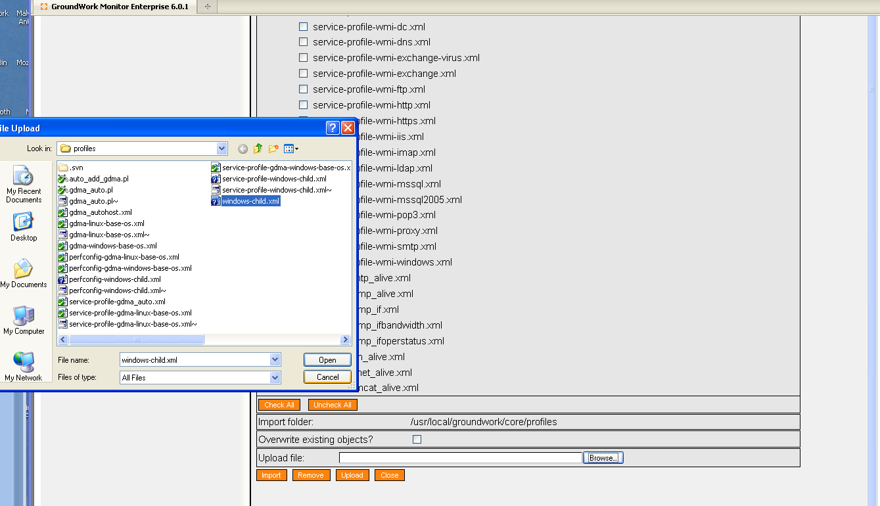

- Toggle Checkbox for windows_child.xml
- Select Import

Create Windows Child Host
This host serves as a collection point for notifications and alerts from the windows child system.

In Configuration→Hosts
- Select Host Wizard
- Fill in Host Name “child-hostname”
- Fill in alias “windows child server”
- Fill in address “xx.xx.xx.xx”
- Select windows_child Host profile

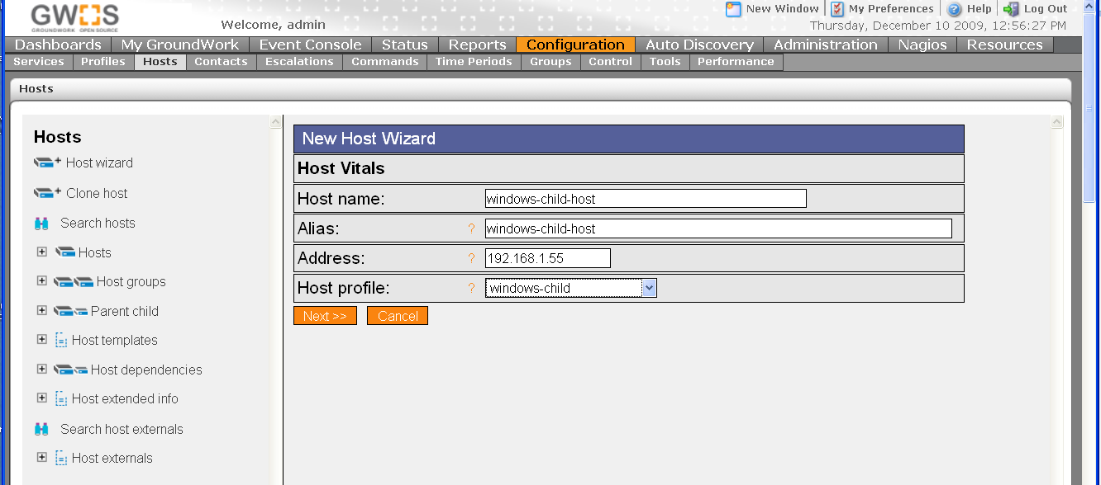

- Select Next,Next,Next,Next,Continue
- Commit Changes to activate

Review and Modify windows-child host externals properties
In Configuration→Hosts→Host Externals
- Select Modify
- Select windows-child

Modify Target_Server parameter
This parameter controls where the windows child will download its host configurations from and where it will send check results. The parameter must be in the form of a URL. This parameter is normally set to the hostname or IP address of the Master system. For details on this and other configuration parameters see GDMA Agent Configuration Reference.

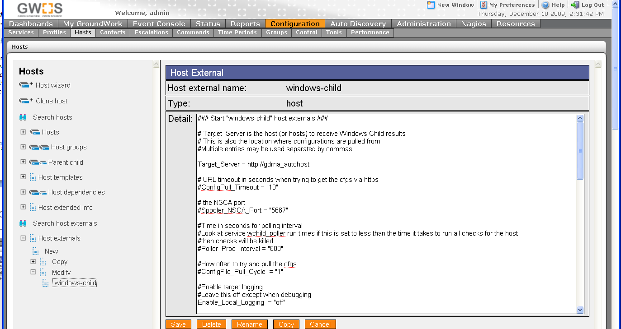

Add windows child host to Monarch Group
In Configuration→Groups
- Expand Groups
- Expand windows-child
- Select Detail
- Select Hosts Tab
- Toggle Checkbox for host E.G. windows-child-host
- Select Add Hosts

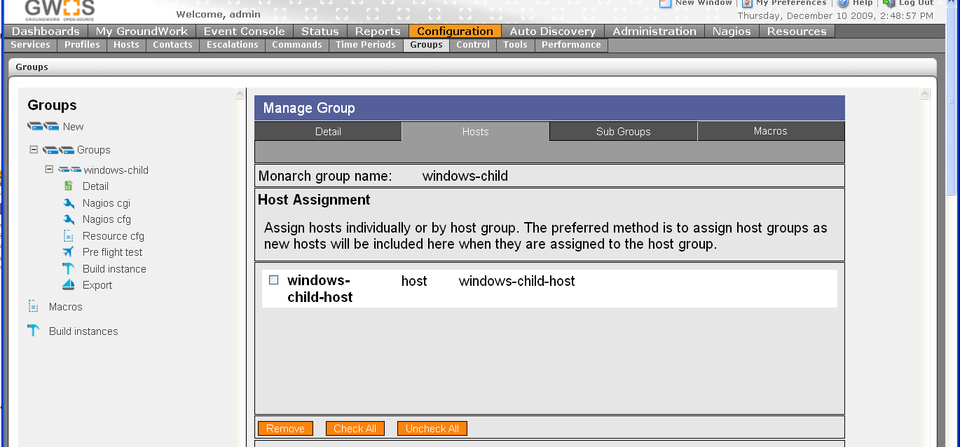

Commit changes and Build Externals
To commit changes to GroundWork and create Windows Child configuration files

In Configuration→Control
- Select Commit, Commit
- Select Run externals

The configuration file will be created in “/usr/local/groundwork/apache2/htdocs/wchild1” as defined in the windows-gdma monarch group. The filename will be gwmon_$hostname.cfg in this example gwmon_windows-child-host.cfg

#ls -al /usr/local/groundwork/apache2/htdocs/wchild1/gwmon_windows-child-host.cfg
-rw-r--r-- 1 nagios nagios /usr/local/groundwork/apache2/htdocs/wchild1/windows-child-host.cfg

Upload and Import Windows Child Target Profiles
The Windows Child Target profile provides configuration parameters for the creation of Windows targets.

In Configuration→Profiles
- Select Profile importer
- Scroll to bottom of screen
- Select Browse and enter location of “windows-child-target.xml”
- Select upload
- Select Browse and enter location of “service-profile-windows-child-target.xml”
- Select upload
- Select Browse and enter location of “perfconfig-windows-child-target.xml”
- Select upload
- Toggle Checkbox for gdma-windows-base-os.xml
- Select Import

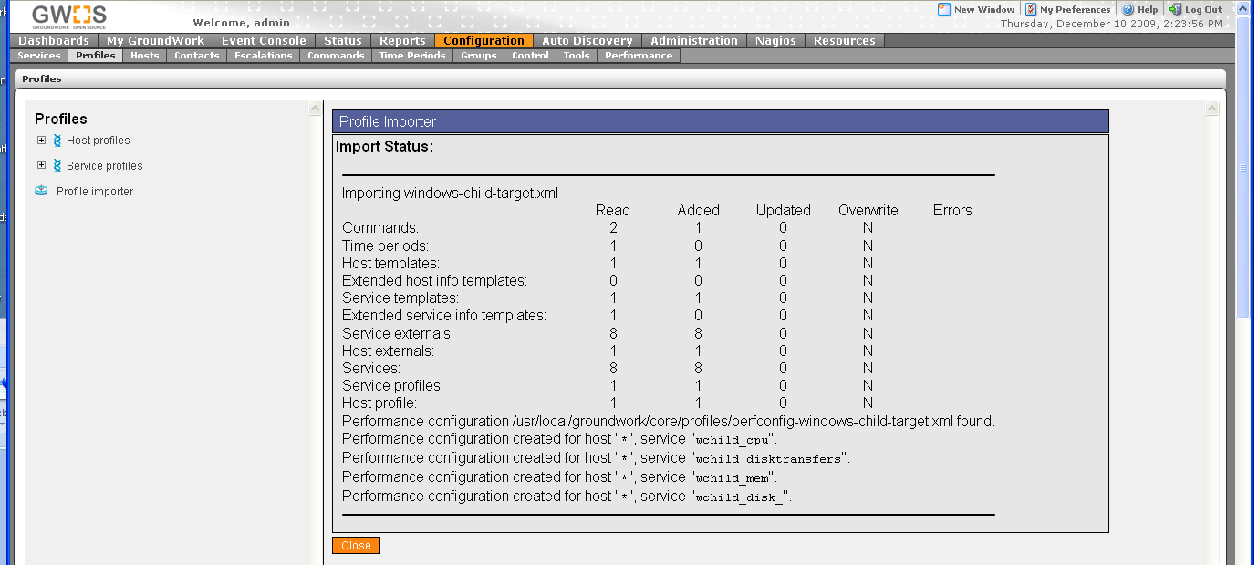

Create/Configure Windows Target

In Configuration→Hosts
- Select Host Wizard
- Fill in Host Name E.G “2000pro”
- Fill in alias E.G.“2000pro”
- Fill in address E.G.“196.168.11.72”
- Select windows-child-target Host profile

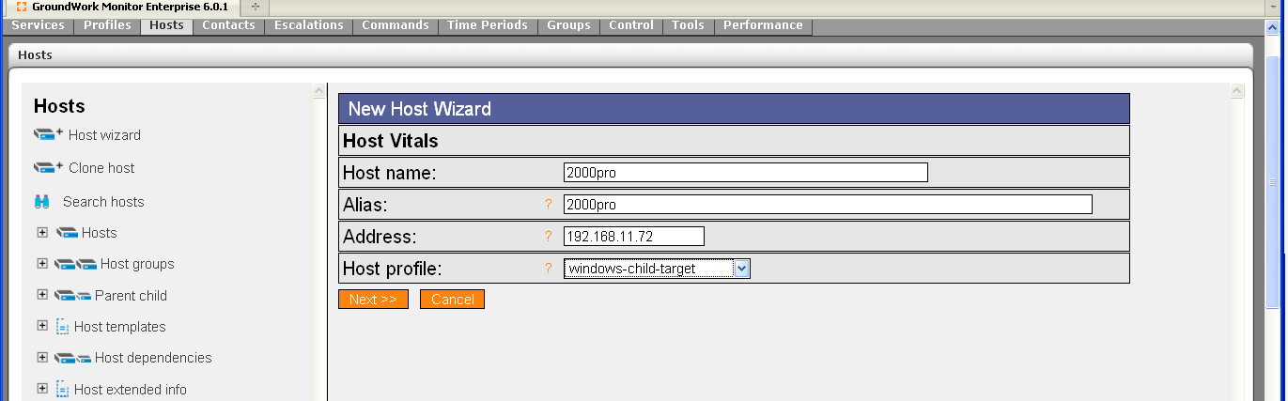

- Select Next,Next,Next,Next,Continue

Add new host to Monarch Group
In Configuration→Groups
- Expand Groups
- Expand windows-child
- Select Detail
- Select Hosts Tab
- Toggle Checkbox for host E.G. 2000pro
- Select Add Hosts

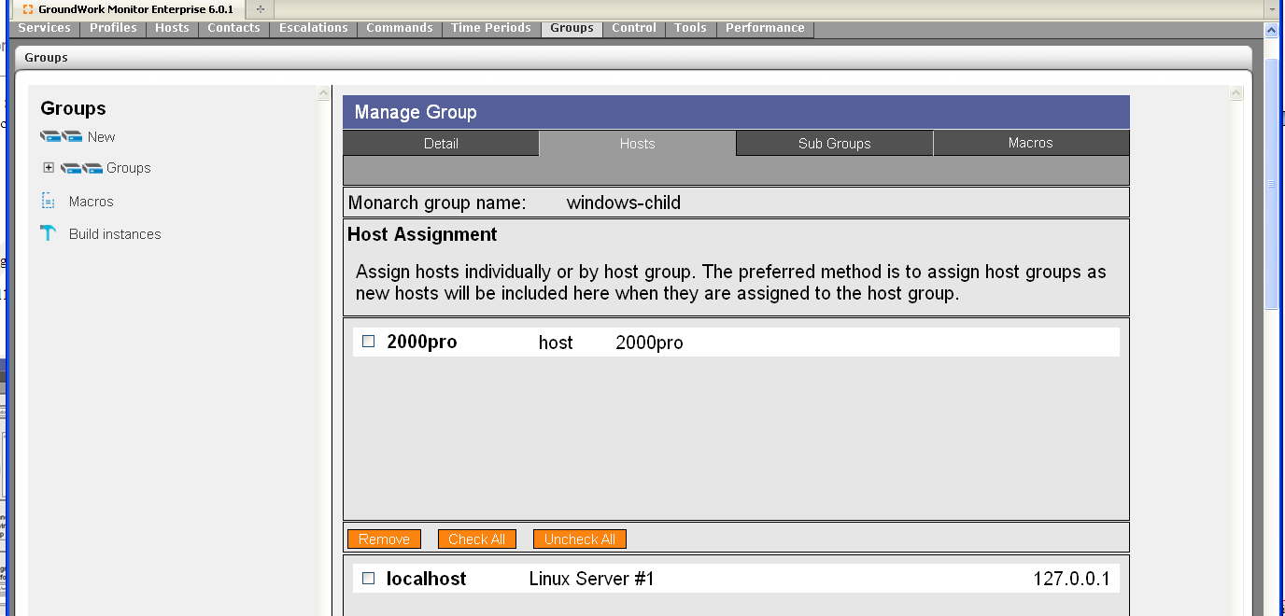

Host will appear in the upper field as an assigned host.

Commit changes and Build Externals
To commit changes to groundwork and create windows child configuration files

In Configuration→Control
- Select Commit, Commit
- Select Run externals

The configuration file will be created in “/usr/local/groundwork/apache2/htdocs/wchild1” as defined in the windows-gdma monarch group. The filename will be gwmon_$hostname.cfg in this example gwmon_2000pro.cfg

#ls -al /usr/local/groundwork/apache2/htdocs/wchild1/gwmon_2000pro.cfg
-rw-r--r-- 1 nagios nagios /usr/local/groundwork/apache2/htdocs/wchild1/gwmon_2000pro.cfg
#

Install Windows Child Software

Use this procedure to install the Windows Child package on a Windows host. Upgrading is not supported. It is suggested that you convert any existing legacy Windows child hosts by adding one new Windows child, and then migrating all the monitored hosts from existing Windows child servers to the new one in a phased migration.

To install a Windows Child:
- Access the Windows client user interface
- Transfer the binary installer file to a temporary location on the local disk
- Start a command window
- Change to the temporary directory
- Type the name of the binary installer, appending “-- multihost 1” to the command

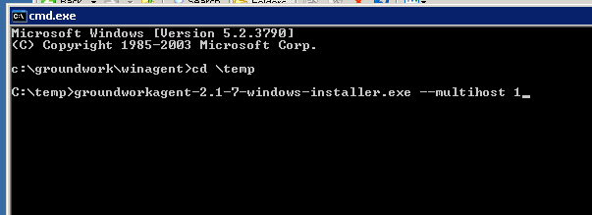

Follow the prompts on the screen.

If you wish to install the Windows Child via a scripted method, such as a software distribution package or a batch script, you may wish to take advantage of the unattended mode option. Type the name of the binary installer followed by “--help” for a list of available options.

Appendix A: GDMA Agent Configuration Reference

This document describes the configuration details and installation methods for GDMA 2.1.

Configuration

In normal operation a GDMA host configuration is generated via the configuration tool Monarch using the “externals” capability. Global configuration parameters are set via a “host external” property and per service parameters are set via a “service external” property. See “Configuring Externals” in the bookshelf for details.

GDMA uses two configuration files to control its operation. These files share the same structure and command parameters.

Autoconfiguration Config
$basedir/config/gdma_auto.cfg is a component of the installation image and governs the behavior of the newly installed agent in an unconfigured state. The purpose of this file is to enable the agent to contact the Target Server and obtain a host configuration file without operator intervention. In general this file should not be modified unless special circumstances require non default auto configuration behavior. This file is also used to enable the agent to revert to autoconfiguration in the event that the host configuration file becomes corrupted or if the Target Server becomes unavailable.

Host Config
$basedir/config/gwmon_$host.cfg is normal mode configuration for the agent. This file overrides all parameters from the autoconfiguration file when it exists. This file will contain the global configuration and per service configuration details for the agent and the services to be monitored.

Global Configuration Parameters

Target_Server
Default Value = http://gdma-autohost
Valid Values = a valid http or https url
Used by Spooler: Yes
Used by Poller: Yes
Description: Defines system where agent will attempt to pull gwmon_$host.cfg file from. This may be in the form of a comma separated list to send results to multiple targets.

Target_Server_Secondary
Default Value =
Valid Values = a valid http or https url
Used by Spooler: Yes
Used by Poller: No
Description: Defines system where agent will attempt send check results when the Target_Server is unavailable.

GDMAConfigDir
Default Value = gdma
Valid Values = valid path string
Used by Spooler: No
Used by Poller: Yes
Description: Defines path where agent will attempt to pull gwmon_$host.cfg file from. This value is concatenated with Target_Server and the hostname of the target system to identify the configuration file to pull.

Example:
gdma_auto.cfg: Target_Server= “http://gdma-autohost”
gdma_auto.cfg: GDMAConfigDir=”gdma”
Target hostname=gdma_test

Would result in the agent pulling its configuration file from
http://gdma-autohost/gdma/gwmon_gdma_test.cfg

Enable_Auto
Default Value = on
Valid Values = on:off
Used by Spooler: Yes
Used by Poller: Yes
Description: Enables and disables auto configuration mode. This should normally be toggled on in gdma_auto.cfg and off in gwmon_$host.cfg

GDMA_Auto_Host
Default Value = gdma-autohost
Valid Values = string conforming to Groundwork/Nagios host object rules
Used by Spooler: Yes
Used by Poller: No
Description: Groundwork Host under which GDMA will submit auto configuration messages.

GDMA_Auto_Service
Default Value = gdma_auto
Valid Values = string conforming to Groundwork/Nagios service object rules
Used by Spooler: Yes
Used by Poller: No
Description: Groundwork Service under which GDMA will submit auto configuration messages.

Poller_Service
Default Value = gdma_poller
Valid Values = string conforming to Groundwork/Nagios service object rules
Used by Spooler: No
Used by Poller: Yes
Description: Groundwork Service under which GDMA will submit poller messages.

Spooler_Service
Default Value = gdma_spooller
Valid Values = string conforming to Groundwork/Nagios service object rules
Used by Spooler: Yes
Used by Poller: No
Description: Groundwork Service under which GDMA will submit spooller messages.

ConfigFile_Pull_Cycle
Default Value = 1
Acceptable Values = 1-10
Used by Spooler: No
Used by Poller: Yes
Description: Controls how often new configuration information should be pulled from the Target Server, The value is a multiple of Poller_Proc_Interval.

ConfigPull_Timeout
Default Value = 10
Acceptable Values = 1-100
Used by Spooler: No
Used by Poller: Yes
Description: Controls how long in seconds to wait before timing out a configuration file pull attempt.
Enable_Local_Logging
Default Value = off
Acceptable Values = on:off
Used by Spooler: Yes
Used by Poller: Yes
Description: Enables local logging of events and errors. Default is off. If this is enabled some provision to clear or rotate logs should be employed.

Logdir
Default Value = /usr/local/groundwork/gdma/log/ or, for Windows GDMA: c:\program files\groundwork\gdma\log
Acceptable Values = absolute directory path
Used by Spooler: Yes
Used by Poller: Yes
Description: Path to write local log files. Must be valid absolute path and writable by agent user.

Poller_Proc_Interval
Default Value = 600
Acceptable Values = 60-900 seconds
Used by Spooler: No
Used by Poller: Yes
Description: Controls how often poller engine will run. Also used as a multiple by ConfigFile_Pull_Cycle and $SERVICE_Check_Interval. Modifying this value is not recommended without understanding the full impact on performance data collection and target system overhead for the environment.

Poller_Pull_Failure_Interval
Default Value = 86400 ( 1 Day)
Acceptable Values = 0- 2592000 seconds (0-30Days)
Used by Spooler: No
Used by Poller: Yes
Description: Controls how long poller will continue to operate in normal mode with the current host configuration after it can no longer pull a configuration file from the Target Server. When this timer expires the poller engine will remove the current host configuration file and revert to auto configuration mode. Setting this value to 0 disables this feature and the agent will continue to operate in normal mode with the stale configuration file indefinitely.

Poller_Plugin_Timeout
Default Value = 5
Acceptable Values = 0- 900 seconds
Used by Spooler: No
Used by Poller: Yes
Description: Controls how long poller will wait for a plugin to execute.

Poller_Plugin_Directory
Default Value = /usr/local/groundwork/gdma/libexec/ or, for Windows GDMA, c:\program files\groundwork\gdma\libexec
Acceptable Values = absolute directory path
Used by Spooler: No
Used by Poller: Yes
Description: Path to local plugins

Spooler_Batch_Size
Default Value = 20
Acceptable Values = integer > 5
Used by Spooler: Yes
Used by Poller: No
Description: Defines max NSCA batch size to use when transmitting results to Target Server.

Spooler_Max_Reties
Default Value = 10
Acceptable Values = integer > 1 and <100
Used by Spooler: Yes
Used by Poller: No
Description: Attempt transmission of results this many times before purging. Multiple of Spooler_Proc_Interval time.

Spooler_Retention_Time
Default Value = 900
Acceptable Values = positive integer and <900
Used by Spooler: Yes
Used by Poller: No
Description: Unsent spooled results older than this number of seconds will be purged.

Spooler_NSCA_Port
Default Value = 5667
Acceptable Values = valid tcp port number
Used by Spooler: Yes
Used by Poller: No
Description: Port to use when transmitting spooled results.

Spooler_NSCA_Timout
Default Value = 5
Acceptable Values = 1-30 seconds
Used by Spooler: Yes
Used by Poller: No
Description: NSCA send timeout

Spooler_Proc_Interval
Default Value = 180
Acceptable Values = 60-900 seconds
Used by Spooler: Yes
Used by Poller: No
Description: Controls how often spooler engine will run. Also used as a multiple by Spooler_Max_Reties.

Spooler_NSCA_Program
Default Value = /usr/local/groundwork/gdma/bin/send_nsca.pl
or
c:\program files\groundwork\gdma\bin\send_nsca.pl
Acceptable Values = absolute path to send nsca program
Used by Spooler: Yes
Used by Poller: No
Description: Location of send nsca program

GDMA_Multihost
Default Value = off
Acceptable Values = on:off
Used by Spooler: No
Used by Poller: Yes
Description: Enable Multihost (windows child) behavior See Windows GDMA Setup section for details

Per Service Configuration Parameters

check_(service)_Enable
Default Value = on
Acceptable Values = on:off
Used by Spooler: No
Used by Poller: Yes
Description: Enable or disable service check

check_(service)_Service
Default Value = n/a
Acceptable Values = string conforming to GroundWork/Nagios service object rules
Used by Spooler: No
Used by Poller: Yes
Description: Groundwork/Nagios service name

check_(service)_Command
Default Value = n/a
Acceptable Values = command definition to be executed by poller
Used by Spooler: No
Used by Poller: Yes
Description: Command definition

check_(service)_Timeout
Default Value = 5
Acceptable Values = 0- 900 seconds
Used by Spooler: No
Used by Poller: Yes
Description: Controls how long poller will wait for a plugin to execute.

Error and Status Messaging
Unless configured with Enable_Local_Logging = on GDMA will not produce any log output on the target system. Normal messaging is returned to the master system via the standard spooling and NSCA transmission methods.

Service | Type of Message | Description | Example
gdma_auto | missing configuration | Indicates unconfigured GDMA host or corrupt configuration file | “gdma-autohost;gdma_auto;3;No configuration file: my_host [192.168.5.13] running MSWin32 5.00”
gdma_spooler | startup message | Indicates normal startup | “my_host;gdma_spooler;0;Spool processor 1.0 started at Wednesday January 6 16:55:27 2010”
 | status message | Indicates normal operation | “my_host;gdma_spooler;0;Spooler transmitted 11 results in 0 secs”
 | transmission failure | Indicates that spooler failed in transmitting results | “my_host;gdma_spooler;2;Failed to transmit 1 results to 192.168.5.74”
 | purge message | Indicates that results are being expired from the spool | “my_host;gdma_spooler;1;Retention timer 900 reached for 38 messages, messages purged”

gdma_poller | status message | Indicates normal operation | “my_host;gdma_poller;0;OK Poller processed 9 checks in 8.547 secs Using 1.42% of 600 sec Polling Interval”
 | startup message | Indicates normal startup | “my_host;gdma_poller;0;Poller 1.0 started at Wednesday January 6 17:01:08 2010”
 | config change | message Indicates that a configuration change has been detected. | “my_host;gdma_poller;1;Configuration change detected :C:\groundwork\gdma\config\gwmon_my_host.cfg at Wednesday January 6 16:13:06 2010”

GDMA switches
gdma_poll and gdma_spool_processor provide the following switches for troubleshooting. These should not be used in normal operation.

Poller Switches

#/usr/local/groundwork/perl/bin/perl gdma_poll.pl -h

GDMA poller agent for version 1.0 monitors system statistics on this server.
Dumps the results to spool file.

Options:
-c <CONFIG FILE> Config file containing monitoring parameters.
-a <AUTOCONF FILE> File with default settings. Must contain a target server address.
-l <LOG DIR> Full path for log directory for this script
-d <1,2> Debug mode. Will log additional messages to the log file, 1 less 2 most.
-h Displays help message.
-x Run once. If this option not selected, run continually with sleep.
-i Run interactively - shows output to the cli (non service mode) as well as to log
-v Show version.

Spooler Switches

/usr/local/groundwork/perl/bin/perl gdma_spool_processor.pl -h

GDMA Spool Processor version 1.0 monitors system statistics on this server.
Results are sent back to the GroundWork server(s) using NSCA.

Options:
-c <CONFIG FILE> Config file containing monitoring parameters.
-a <AUTOCONF FILE> File with default settings. Must contain a target server address.
-l <LOG DIR> Log directory for this script, relative to GDMA HOME.
-d <1,2> Debug mode. Will log additional messages to the log file, 1 less 2 most.
-h Displays help message.
-x Run once. If this option not selected, run continually with sleep.
-i Run interactively - shows output to the cli (non service mode) as well as to log
-v Show version.

GDMA operation requires a unified time base for Target servers and the monitored systems. This is normally accomplished using an external clock source such as NTP (Network Time Protocol) for all systems. Messages from systems with out of sync clocks may be dropped silently by the Bronx event broker.
See Fig 1, Poller Operation for details
See Fig 2, Spooler Operation for details
This name is controlled by the GDMA_Auto_Host Configuration parameter. Do not modify this path without also modifying all the requisite GDMA agent configurations.
Nagios and Groundwork require that all IP addresses for configured hosts be unique. Ensure that the address used here is unique in the configuration.
You may optionally place the gdma-autohost in a hostgroup and configure notification options.
See Bookshelf Using Applications→Configuration→Configuration Scenarios→Configuring Externals
This directory is controlled by the GDMAConfigDir Configuration parameter. Do not modify this path without also changing the relevant GDMA agent parameters.
You may optionally place the host in a hostgroup and configure additional host, service and notification options.
This directory is controlled by the GDMAConfigDir Configuration parameter. Do not modify this path without also changing the relevant GDMA agent parameters.
See Bookshelf Using Applications→Configuration→Configuration Scenarios→Configuring Externals
This directory is controlled by the GDMAConfigDir Configuration parameter. Do not modify this path without changing appropriate GDMA agent parameters to match.
You may optionally place the host in a hostgroup and configure additional host, service and notification options.
This directory is controlled by the GDMAConfigDir Configuration parameter. Do not modify this path without also changing the relevant GDMA agent parameters.
Windows Child operation requires a unified time base for master system and the windows child. This is normally accomplished using an external clock source such as NTP (Network Time Protocol) for all systems.
See Bookshelf Using Applications→Configuration→Configuration Scenarios→Configuring Externals
This directory is controlled by the GDMAConfigDir Configuration parameter. Do not modify this path without consulting GDMA agent documentation.
You may optionally place the host in a hostgroup and configure additional host, service and notification options.

